What is PySpark DStream (Discretized Stream) Module?
PySpark DStream is the original streaming abstraction in Spark Streaming that lets you process real-time data streams in small batches (micro-batches) using the familiar RDD-based API.
In simple terms:
A DStream = a continuous stream of data represented as a sequence of RDDs, created at fixed time intervals (batch duration).

Why DStream Exists
Before Structured Streaming, Spark introduced DStreams to bring real-time processing to Spark while reusing the batch engine.
It was designed to:
- Handle real-time data
- Work with RDD transformations
- Support fault tolerance
- Integrate easily with Spark Core
How DStream Works (Internally)
- Data arrives from a source (socket, Kafka, file, etc.)
- Data is divided into micro-batches (e.g., every 5 seconds)
- Each micro-batch becomes an RDD
- Transformations run on each RDD
- Output is written to console / file / database

Live Data → Micro-Batches → RDDs → Processing → Output

Key Characteristics of DStream
Feature | Description
Processing model | Micro-batch
Core data structure | RDD
API style | Functional (map, reduce, filter)
Latency | Seconds (not milliseconds)
Fault tolerance | Achieved via RDD lineage
Window operations | Supported
State management | Limited (updateStateByKey)

Common DStream Sources
- SocketTextStream (testing)
- Kafka (old integration)
- Flume
- File-based streaming (CSV, JSON, TXT)
Example sources:

Start Streaming Data (Socket Server)
Open Command Prompt and run:
ncat -lk 9999
Now type messages like:
hello spark
hello streaming
spark spark python
This terminal is now your real-time data source.

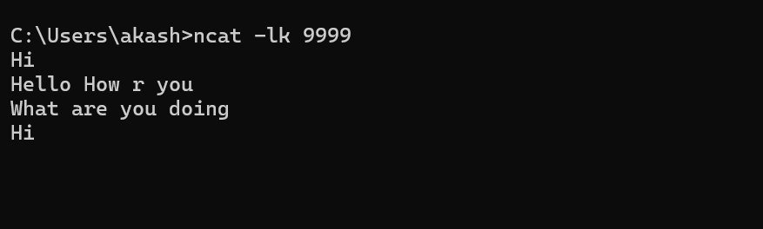

Create StreamingContext
ssc = StreamingContext(sc, 5)
📌 5 seconds = batch interval
Every 5 seconds → Spark creates one RDD

🧩 STEP 7: Read Streaming Text Data (CORE STEP)
lines = ssc.socketTextStream("localhost", 9999)
📌 Connects to:
- Host → localhost
- Port → 9999 (nc server)
📌 Each line typed = one record

🧩 STEP 8: Display the Streaming Data
lines.pprint()
📌 Prints streaming data to console
📌 Shows max 10 records per batch

🧩 STEP 9: Start Streaming
ssc.start()
ssc.awaitTermination()
📌 Starts streaming
📌 Keeps application running forever

dstreamtext_data.py
from pyspark import SparkConf, SparkContext
from pyspark.streaming import StreamingContext

# 1. Spark Config
conf = SparkConf() \
.setAppName("SimpleTextStream") \
.setMaster("local[2]")

sc = SparkContext(conf=conf)
sc.setLogLevel("ERROR")

# 2. Streaming Context (5 seconds)
ssc = StreamingContext(sc, 5)

# 3. Read streaming text data from socket
lines = ssc.socketTextStream("localhost", 9999)

# 4. Display data as-is
lines.pprint()

# 5. Start streaming
ssc.start()
ssc.awaitTermination()

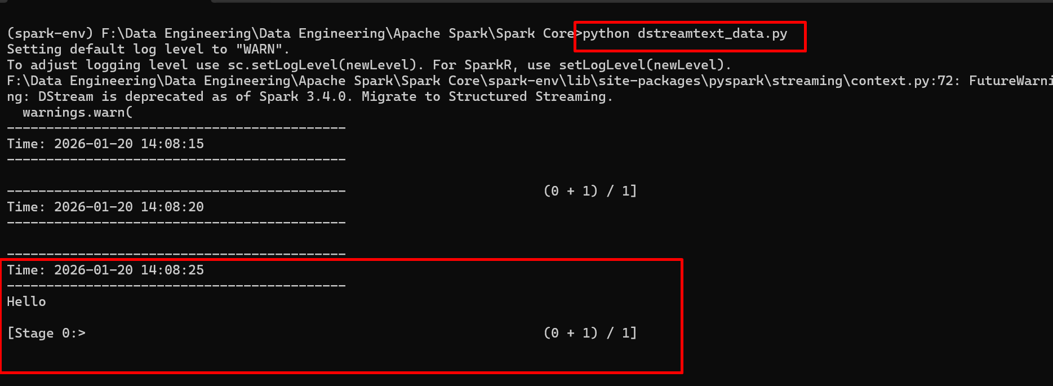

Next example to dstream word count

dstream_wordcount.py
from pyspark import SparkConf, SparkContext
from pyspark.streaming import StreamingContext

# 1. Spark Configuration
conf = SparkConf() \
.setAppName("PySparkStreamingWordCount") \
.setMaster("local[2]")

sc = SparkContext(conf=conf)
sc.setLogLevel("ERROR")

# 2. Streaming Context (batch interval = 5 seconds)
ssc = StreamingContext(sc, 5)

# 3. Create DStream from socket
lines = ssc.socketTextStream("localhost", 9999)

# 4. Transformations
words = lines.flatMap(lambda line: line.split(" "))
word_pairs = words.map(lambda word: (word, 1))
word_counts = word_pairs.reduceByKey(lambda a, b: a + b)

# 5. Output
word_counts.pprint()

# 6. Start Streaming
ssc.start()
ssc.awaitTermination()

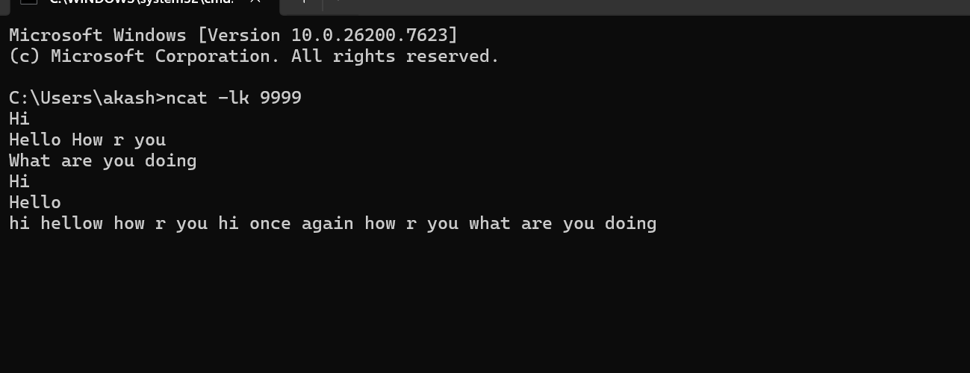

After run the example as

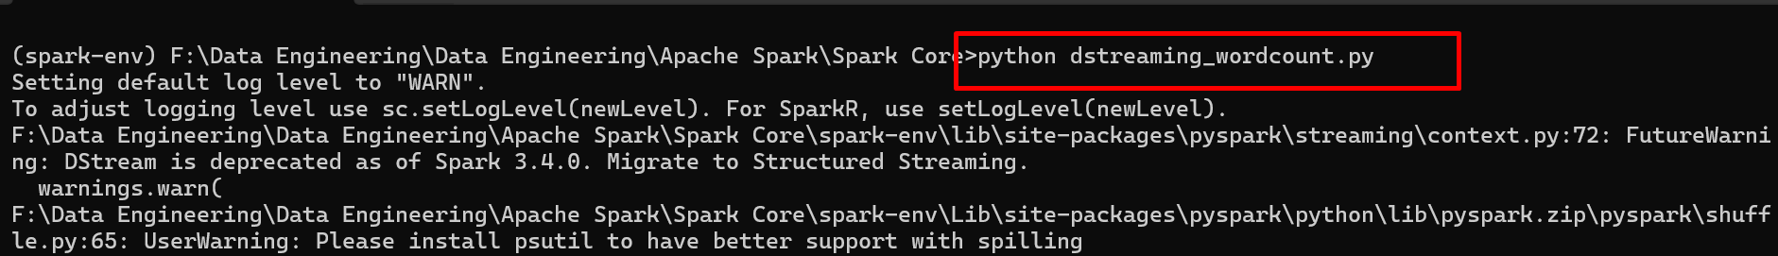

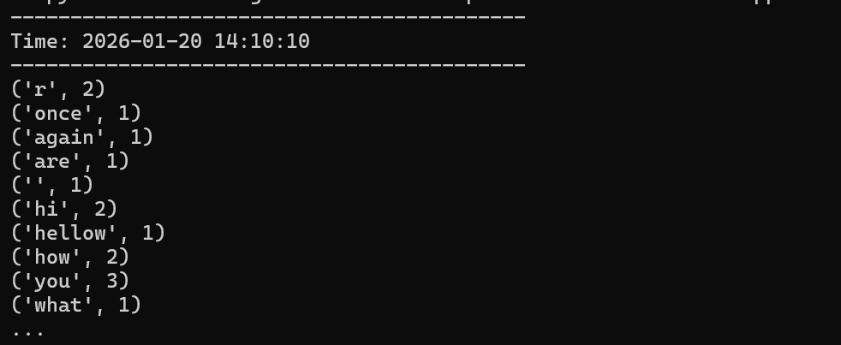

Both DStream and Structured Streaming are streaming models in Apache Spark, but they differ greatly in API design, ease of use, fault tolerance, and future support.

1️⃣ What is DStream (Discretized Stream)?
DStream is the old Spark Streaming API (Spark 1.x era).
🔹 Core Idea
- A stream = sequence of RDDs
- Data processed in micro-batches
- Programmer works directly with RDDs
🔹 Flow

Input Stream → Micro-batches → RDD → Transformations → Output
🔹 Characteristics
- Low-level API
- Manual checkpointing
- Harder window & state handling
- Limited SQL support
- Being phased out ❌

2️⃣ What is Structured Streaming?
Structured Streaming is the modern streaming engine (Spark 2.x+).
🔹 Core Idea
- Stream treated as an unbounded table
- Uses DataFrame / Dataset API
- Same code for batch & streaming
🔹 Flow
Input Source → Unbounded Table → SQL / DataFrame Ops → Sink
🔹 Characteristics
- High-level & declarative
- Built-in fault tolerance
- Exactly-once semantics
- Native SQL support
- Actively developed ✅

Streams vs Structured Streaming (Summary)
Feature | DStreams | Structured Streaming
API | RDD | DataFrame
SQL | Limited | Full
State Mgmt | Manual | Automatic
Future | Deprecated | Recommended

3️⃣ Key Differences (Side-by-Side)
Feature | DStream | Structured Streaming
API Level | Low-level (RDD) | High-level (DataFrame/Dataset)
Introduced | Spark 1.x | Spark 2.x+
Programming Style | Imperative | Declarative
Batch vs Stream Code | Separate | Same code
SQL Support | ❌ No | ✅ Yes
Fault Tolerance | Manual | Automatic
Window Operations | Complex | Simple
Exactly-once | Hard | Built-in
Future Support | ❌ Deprecated | ✅ Recommended

PySpark Streaming means processing data continuously in real time (or near real time) using Apache Spark with Python (PySpark).
Let me explain this clearly, simply, and practically, with uses and real-world meaning 👇

1️⃣ What is PySpark Streaming?
PySpark Streaming is used to process data that is coming continuously, instead of data that is already stored.
➡️ Data arrives every second / minute
➡️ Spark processes it as it arrives
➡️ Results are produced continuously
Simple definition
PySpark Streaming = Real-time data processing using Spark + Python

2️⃣ Why do we need Streaming?
Traditional Spark (batch processing):
- Reads static data (files, tables)
- Processes once
- Produces output
Streaming Spark:
- Reads live data
- Processes continuously
- Produces results again and again

3️⃣ Real-Life Example (Very Important)
🚦 Traffic Camera System
- Cameras send vehicle data every second
- Need to count vehicles live
- Need alerts for congestion immediately
➡️ Batch Spark ❌ (too late)
➡️ PySpark Streaming ✅

4️⃣ Common Use Cases of PySpark Streaming
✅ 1. Live Log Monitoring
- Application logs coming every second
- Detect errors or failures instantly
✅ 2. Financial Transactions
- Credit card swipes
- Detect fraud in real time
✅ 3. Social Media Analytics
- Live tweets
- Trending hashtags
✅ 4. IoT / Sensor Data
- Temperature sensors
- Smart meters
- Health devices
✅ 5. Stock Market Analysis
- Live price updates
- Alerts for sudden changes

stream_word_count.py

from pyspark.sql import SparkSession
from pyspark.sql.functions import explode, split

spark = SparkSession.builder.appName("StructuredStreaming").getOrCreate()

df = spark.readStream.format("socket") \
.option("host","localhost") \
.option("port",9999) \
.load()

words = df.select(explode(split(df.value," ")).alias("word"))

counts = words.groupBy("word").count()

query = counts.writeStream \
.outputMode("complete") \
.format("console") \
.start()

query.awaitTermination()

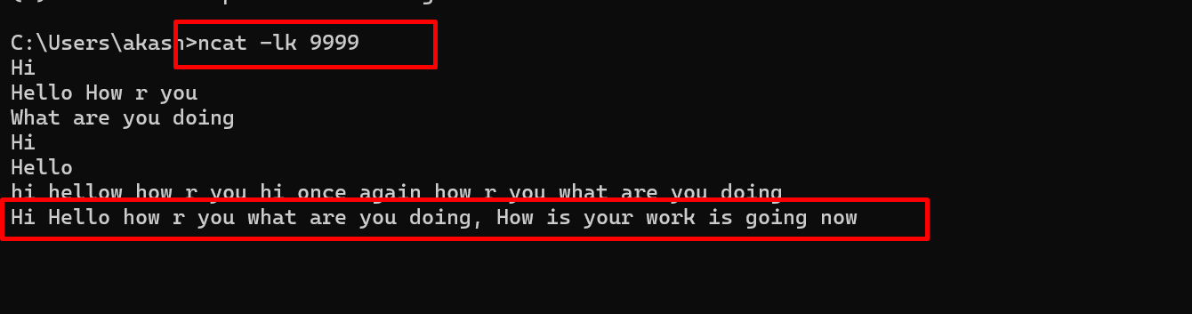

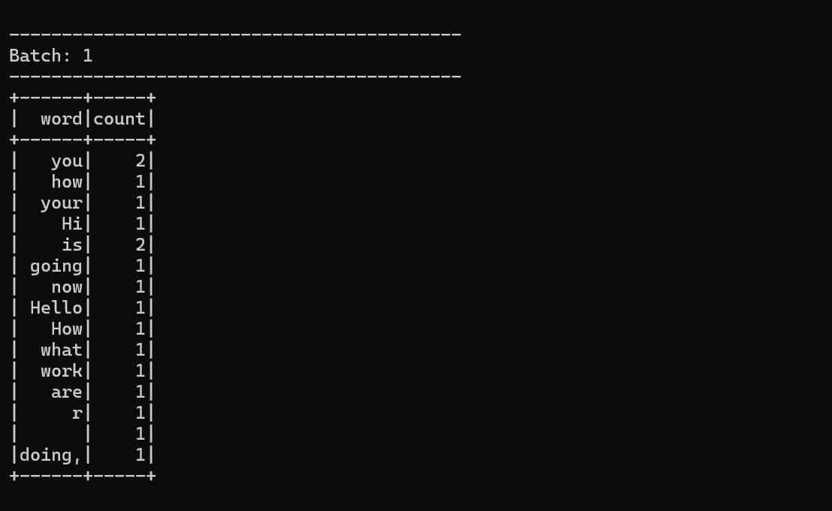

Example 2️⃣ File Streaming (Real-Time Folder Monitoring)
Use Case
- Streaming logs
- Transaction files
- Sensor data

Directory Structure (Windows)
Create folders:
C:\spark_streaming\
├── input_csv\
├── input_json\
├── checkpoint\
└── output\

PART A — CSV File Streaming

Step 2: Sample CSV Schema
Assume incoming CSV files like:

id,name,amount
1,Alice,100
2,Bob,200

csv_streaming.py

from pyspark.sql import SparkSession
from pyspark.sql.types import StructType, StructField, IntegerType, StringType
from pyspark.sql.functions import sum

# 1. Spark Session
spark = SparkSession.builder \
.appName("CSVFileStreaming") \
.master("local[2]") \
.getOrCreate()

spark.sparkContext.setLogLevel("ERROR")

# 2. Define schema (REQUIRED for streaming)
schema = StructType([
StructField("id", IntegerType(), True),
StructField("name", StringType(), True),
StructField("amount", IntegerType(), True)
])

# 3. Read CSV stream
df = spark.readStream \
.format("csv") \
.schema(schema) \
.option("header", "true") \
.load("C:/spark_streaming/input_csv")

# 4. Transformation
result = df.groupBy("name").agg(sum("amount").alias("total_amount"))

# 5. Write stream
query = result.writeStream \
.outputMode("complete") \
.format("console") \
.option("checkpointLocation", "C:/spark_streaming/checkpoint/csv") \
.start()

query.awaitTermination()

python csv_streaming.py

Step 5: Add CSV Files (Simulate Streaming)
Create new file after Spark starts:

C:\spark_streaming\input_csv\batch1.csv
id,name,amount
1,Alice,100
2,Bob,200
Then add another:

cat > batch2.csv
id,name,amount
3,Alice,300
4,Bob,50

Correct Ways to Add Files (Windows-safe)
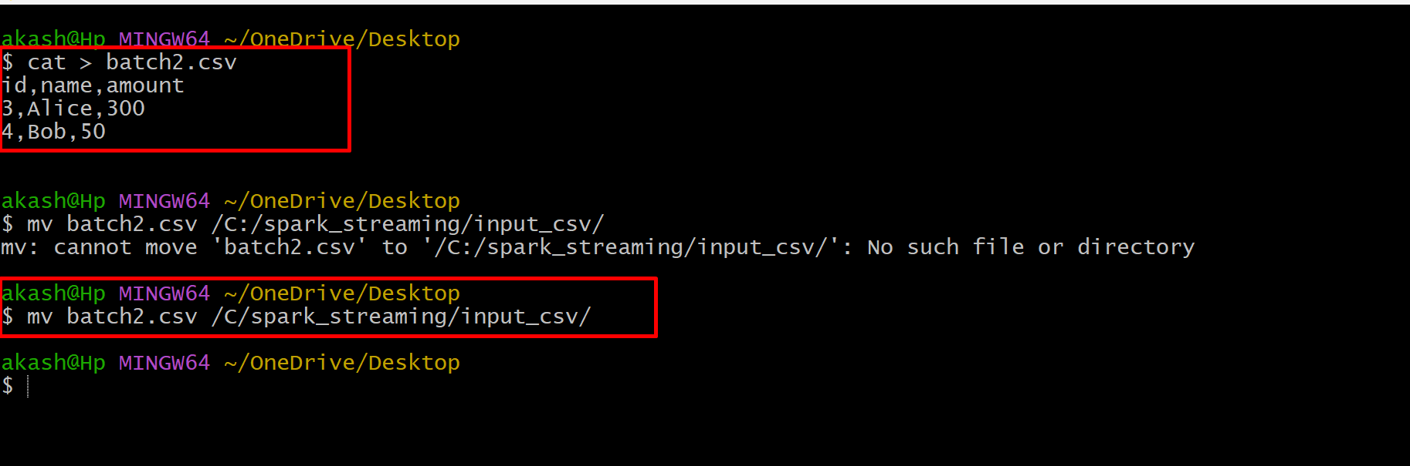

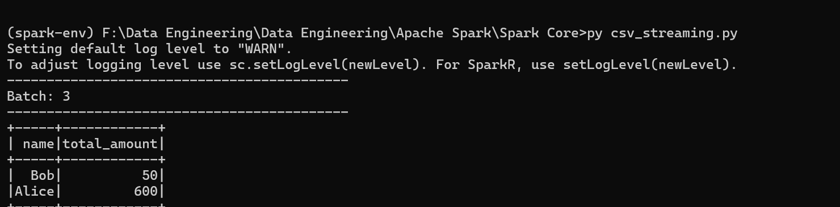

Json_steraming.py

from pyspark.sql import SparkSession
from pyspark.sql.types import StructType, StructField, IntegerType, StringType
from pyspark.sql.functions import sum

spark = SparkSession.builder \
.appName("JSONFileStreaming") \
.master("local[2]") \
.getOrCreate()

spark.sparkContext.setLogLevel("ERROR")

schema = StructType([
StructField("id", IntegerType(), True),
StructField("product", StringType(), True),
StructField("price", IntegerType(), True)
])

df = spark.readStream \
.schema(schema) \
.json("C:/spark_streaming/input_json")

result = df.groupBy("product") \
.agg(sum("price").alias("total_price"))

query = result.writeStream \
.format("console") \
.outputMode("complete") \
.option("checkpointLocation", "C:/spark_streaming/checkpoint/json") \
.start()

query.awaitTermination()

